Imagine you have two separate tables: one with customer information (like CustomerID and CustomerName), and another with order information (like OrderID and CustomerID).
The CustomerID column exists in both tables. This is the "related column" that connects them. A JOIN allows you to combine the data from both tables so you can see, for example, the name of the customer who placed a specific order.
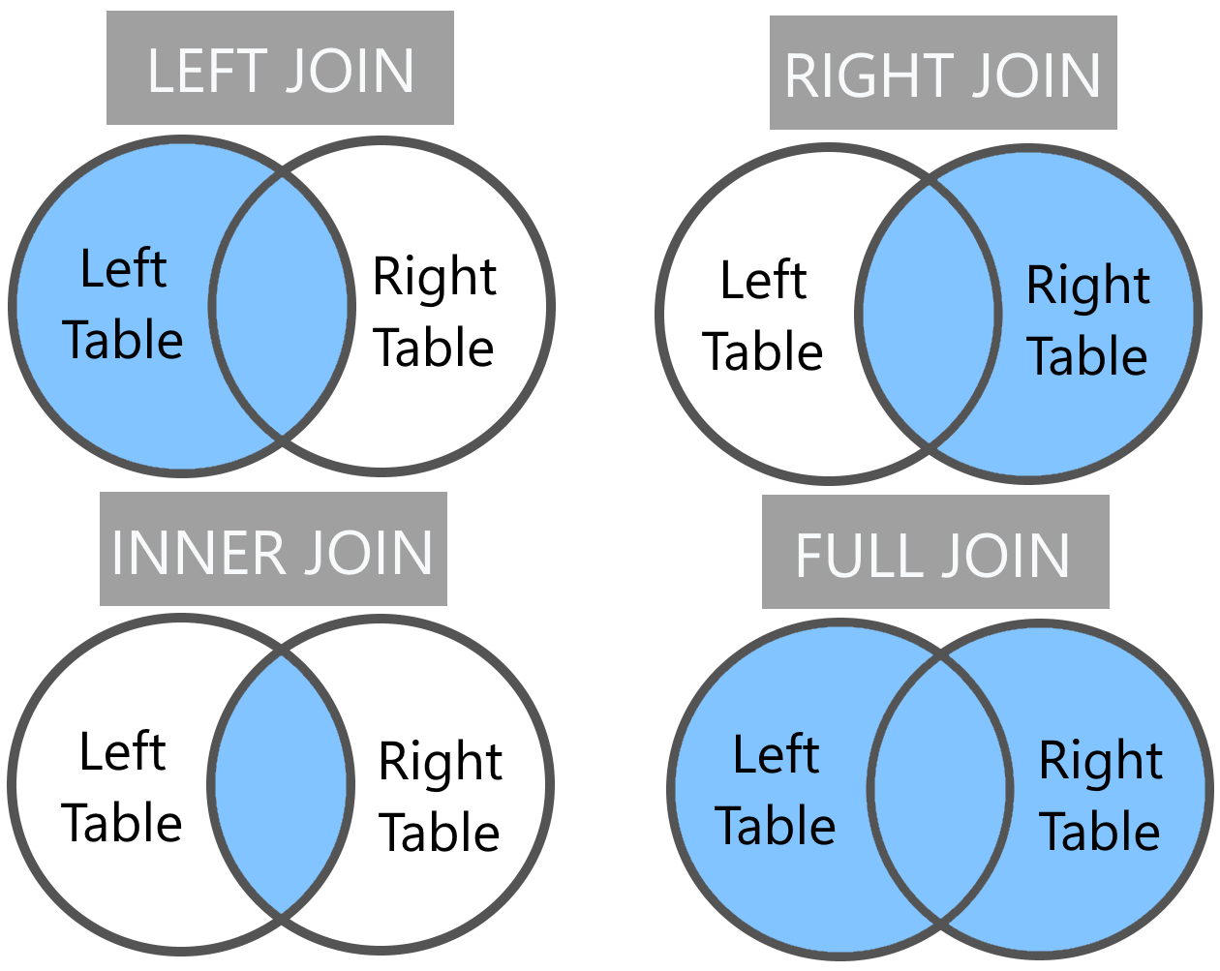

The Main Types of SQL JOINS
The different types of joins determine which rows are included in the final result set, based on whether a match is found in the other table.

1. INNER JOIN
An INNER JOIN is the most common type of join. It returns only the rows that have matching values in both tables.
- Analogy: Think of it as finding the intersection of two sets. You only get the things that are common to both.
- Explanation:
  - The database engine looks at the ON condition you provide (e.g., Customers.CustomerID = Orders.CustomerID).
  - If a CustomerID from the Customers table has a corresponding CustomerID in the Orders table, the row is included in the result.
  - If a customer has no orders, they will not appear in the result.
  - If an order has a CustomerID that doesn't exist in the Customers table, that order will not appear.
- Syntax:
- Use Case: Finding a list of all orders that have a customer assigned to them.

2. LEFT (OUTER) JOIN
A LEFT JOIN returns all rows from the "left" table, and the matching rows from the "right" table. If there is no match in the right table, the result for that table's columns will be NULL.
- Analogy: You're starting with everything on the left side of the intersection. You're bringing in whatever matches from the right, but if there's no match, that space is left blank (with NULL).
- Explanation:
  - The "left" table is the one listed first in the FROM clause.
  - The "right" table is the one listed after JOIN.
  - Every row from the left table is guaranteed to be in the result.
  - If a row from the left table doesn't have a match in the right table, the columns from the right table will show NULL values.
- Syntax:
- Use Case: Getting a list of all customers, and their order details if they have any. This would show customers with orders, and also customers who haven't placed any orders yet.

3. RIGHT (OUTER) JOIN
A RIGHT JOIN is the mirror image of a LEFT JOIN. It returns all rows from the "right" table, and the matching rows from the "left" table. If there is no match in the left table, the result for that table's columns will be NULL.
- Analogy: Everything from the right side of the intersection is your starting point. You bring in whatever matches from the left.
- Explanation:
  - The "right" table is the one listed after JOIN.
  - The "left" table is the one listed first in the FROM clause.
  - Every row from the right table is guaranteed to be in the result.
  - If a row from the right table doesn't have a match in the left table, the columns from the left table will show NULL values.
- Syntax:
- Use Case: Getting a list of all orders, and the customer details for each order. This would show orders with a valid customer, and also "orphaned" orders with no matching customer. (In practice, a LEFT JOIN is more commonly used and the tables are simply swapped).

4. FULL (OUTER) JOIN
A FULL JOIN returns all rows when there is a match in either of the tables. It is a combination of a LEFT JOIN and a RIGHT JOIN.
- Analogy: Think of a Venn diagram. This is the entire union of both circles—all data from both tables.
- Explanation:
  - The result set includes all matching rows from both tables.
  - It also includes non-matching rows from the left table (with NULL values for the right table's columns).
  - It also includes non-matching rows from the right table (with NULL values for the left table's columns).
- Syntax:
- Use Case: Finding a complete list of all customers and all orders, to see which customers have orders, which customers don't, and which orders don't have a customer assigned. This is often used for data cleaning and identifying inconsistencies.

Other Less Common Joins (for a more advanced class)
- CROSS JOIN: Returns the Cartesian product of the two tables. This means every row from the first table is joined with every row from the second table. This is rarely used in typical applications.
- SELF JOIN: A regular join (usually INNER or LEFT) where a table is joined with itself. This is useful for hierarchical data, like an Employees table that has a ManagerID column which refers to another employee's EmployeeID.

Summary Table
JOIN Type | Result | Key Concept
INNER JOIN | Rows with matching values in both tables. | Intersection
LEFT JOIN | All rows from the left table, and matched rows from the right. | Left-side dominance
RIGHT JOIN | All rows from the right table, and matched rows from the left. | Right-side dominance
FULL JOIN | All rows from both tables, with NULLs where there is no match. | Union

